**Questions and Answers – Group 12**

1. **Draw a block diagram illustrating how you would connect an MPU6050 accelerometer/gyroscope sensor to an ESP32 microcontroller. Explain the purpose of each component and the communication protocol used between the sensor and the microcontroller.**

Some Diagram depicting the below image:

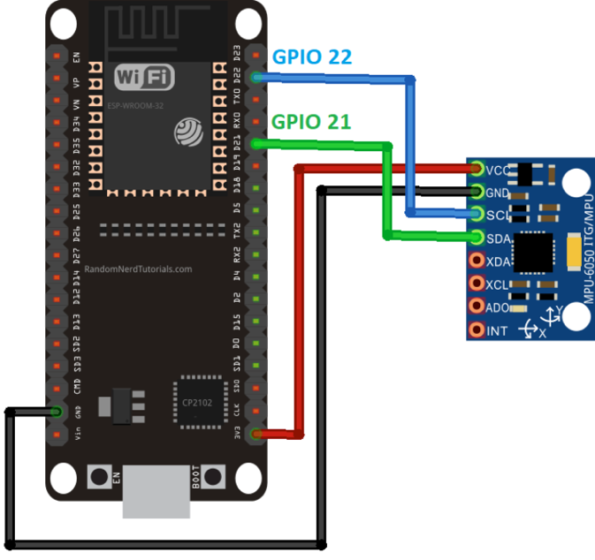

The ESP32 microcontroller is connected to the MPU6050 sensor via the I2C (Inter-Integrated Circuit) communication protocol.

The ESP32 acts as the master device, and the MPU6050 acts as the slave device on the I2C bus. The ESP32's GPIO (General-Purpose Input/Output) pins are used for the I2C clock (SCL) and data (SDA) lines to communicate with the MPU6050. The MPU6050 is an inertial measurement unit (IMU) that combines an accelerometer and a gyroscope to measure linear acceleration and angular velocity, respectively.

1. **List at least 5 key features and specifications of the Arduino Uno board that make it suitable for IoT projects involving sensor data acquisition and processing.**

* Microcontroller: ATmega328P, a low-power 8-bit AVR microcontroller
* Operating Voltage: 5V
* Digital I/O Pins: 14 (6 of which can be used as PWM outputs)
* Analog Input Pins: 6
* Flash Memory: 32 KB (0.5 KB used by bootloader)
* SRAM: 2 KB
* EEPROM: 1 KB
* Clock Speed: 16 MHz
* USB Communication: Built-in USB interface for programming and serial communication
* Power Supply: Can be powered via USB or an external power supply

1. **Suppose you have an IoT project where you need to measure the distance between an object and a wall using an ultrasonic sensor connected to an ESP32. The distance should be continuously monitored, and if it falls below a certain threshold, an alert should be sent to a remote server via Wi-Fi. Draw a flow chart illustrating the overall system design and the steps involved in this process.**

The flowchart illustrates the overall system design and steps involved in the IoT project. Here's a breakdown of the process:

1. Start the program.
2. Initialize the necessary components, including the ESP32 microcontroller, ultrasonic sensor, and Wi-Fi module.
3. Connect the ESP32 to the desired Wi-Fi network for internet connectivity.
4. Measure the distance between the object and the wall using the ultrasonic sensor.
5. Check if the measured distance is below a predefined threshold.
6. If the distance is below the threshold, send an alert to a remote server via Wi-Fi.
7. If the distance is above or equal to the threshold, no action is taken.
8. Wait for a specified interval before taking the next distance measurement.
9. Repeat steps 4-8 in a continuous loop to continuously monitor the distance and send alerts as needed.

This system design allows for continuous monitoring of the distance between an object and a wall using an ultrasonic sensor connected to an ESP32 microcontroller. If the distance falls below a certain threshold, an alert is sent to a remote server via Wi-Fi for further processing or notification.

1. **Imagine you are building an IoT-enabled fitness tracker using an Arduino Uno and an MPU6050 sensor. The device should be able to track the user's step count, cadence (steps per minute), and calories burned based on the accelerometer data. List the key components and sensors required for this project, and describe the high-level algorithm or pseudocode for processing the sensor data and calculating the desired metrics.**

Key components and sensors required:

* Arduino Uno microcontroller
* MPU6050 accelerometer and gyroscope sensor
* Battery or power source
* Enclosure or wearable housing for the device
* (Optional) Bluetooth or Wi-Fi module for data transmission
* (Optional) Display or LED indicators for real-time feedback

The algorithm follows these steps:

1. Initialize variables to keep track of step count, previous acceleration, cadence, calories burned, and a predefined step detection threshold.
2. In a continuous loop, read the accelerometer data (x, y, z) from the MPU6050 sensor.
3. Calculate the magnitude of the acceleration vector using the Pythagorean theorem.
4. Detect a step by checking if the change in acceleration magnitude from the previous value exceeds the step detection threshold.
5. If a step is detected, increment the step count and update the time for cadence calculation.
6. Calculate the steps per minute based on the step count and the time elapsed since the last step detection.
7. Calculate the calories burned based on the step count, the user's weight, and a calibration factor.
8. Update the previous acceleration value for the next iteration.
9. (Optional) Display the step count, cadence, and calories burned on a screen or LED indicators for real-time feedback.
10. (Optional) Transmit the data to a connected device or cloud service for further analysis or storage.
11. Wait for a short interval before the next loop iteration to avoid overwhelming the processor with continuous calculations.
12. **What is the I2C communication protocol used for in IoT projects?**

The I2C (Inter-Integrated Circuit) communication protocol is widely used in IoT projects for connecting multiple devices and sensors to a microcontroller or microprocessor. It allows for bidirectional communication over just two wires (SDA and SCL), making it an efficient and space-saving solution for IoT applications. I2C is commonly used to interface sensors like the MPU6050 with microcontrollers in IoT projects.

**Information about sensors used in our project**

**MPU6050**:

Key Details:

* Integrated 3-axis gyroscope and 3-axis accelerometer.
* Digital motion processing (DMP) unit for complex calculations.
* I2C communication interface for easy integration with microcontrollers.
* Low power consumption, making it suitable for battery-operated devices.
* Small form factor and low cost.
* Operating voltage typically ranges from 2.3V to 3.4V.

Workings:

* Gyroscope measures angular velocity in degrees per second (°/s).
* Accelerometer measures acceleration in meters per second squared (m/s²).
* Data from both sensors are combined to calculate orientation using sensor fusion algorithms.

Usage:

* Robotics: for balancing, orientation control, and gesture recognition.
* Drones: for stabilization, attitude control, and flight path tracking.

**Ultrasonic Sensors:**

Key Details:

* Emit ultrasonic waves (>20 kHz) and measure the time taken for the waves to bounce back.
* Typically consist of a transmitter, receiver, and control circuitry.
* Operating range varies from a few centimeters to several meters.
* Can be either analog or digital output.
* Some sensors feature adjustable sensitivity and beam width.
* Common types include single transducer, dual transducer, and phased-array sensors.

Workings:

* Speed of sound (c) in air is approximately 343 meters per second at room temperature.
* Distance (d) to the object is calculated using the formula: d=1/2×c×t

where t is the time taken for the ultrasonic pulse to travel to the object and back.

* To compensate for temperature variations, sensors may include temperature sensors or calibration routines.
* Beam angle affects the detection area and resolution of the sensor.
* Multiple measurements or averaging can improve accuracy, especially in noisy environments.
* Ultrasonic sensors are susceptible to interference from obstacles with uneven or absorbent surfaces.

Usage:

* Automotive: for parking assistance, obstacle detection, and blind spot monitoring.
* Industrial automation: for object detection, level sensing, and distance measurement.